**Introduction**

New York is the [most populous city](https://en.wikipedia.org/wiki/List_of_United_States_cities_by_population) in the [United States](https://en.wikipedia.org/wiki/United_States) . New York is also the [most densely populated](https://en.wikipedia.org/wiki/List_of_United_States_cities_by_population_density) major city in the United States. New York City has been described as the [cultural](https://en.wikipedia.org/wiki/Culture_of_New_York_City), financial, and media capital of the world, significantly influencing commerce, entertainment, research, technology, education, politics, tourism, art, fashion, and sports . New York is home residents born outside the United States  the largest foreign-born population of any city in the world .There are many languages are spoken in New York .This makes this city extremely diverse .With its diverse culture there are many food culture / restaurants available in City . As part of this project we will try to navigate different area of New York and determine which area has best Indian restaurants.

**Data**

For this project we will use Data source : <https://cocl.us/new_york_dataset> to collect boroughs and Neighborhoods information. We will use Foursquare API to collect restaurants *information , rating .*

**Approach**

We will first collect New York City data .

Using Foursquare API we will find venue for each area.

Filter out data only with Indian restaurants and find rating ,tips etc information .

We will use rating and sort the data .

**Analysis and Results**

As per above approach we have analyzed the data and got results .

Few observations:

Queens has the highest number of Neighborhoods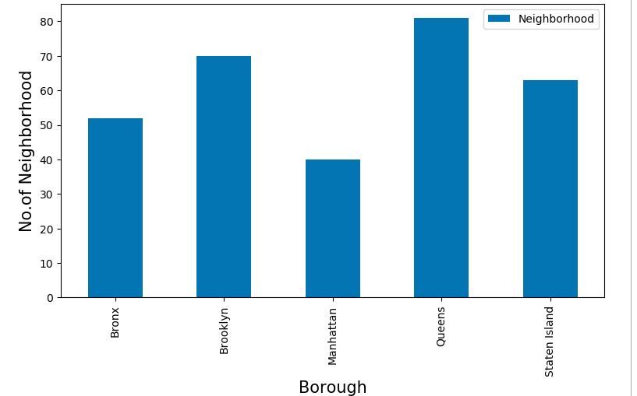

Also Queens has highest number of Indian restaurants:

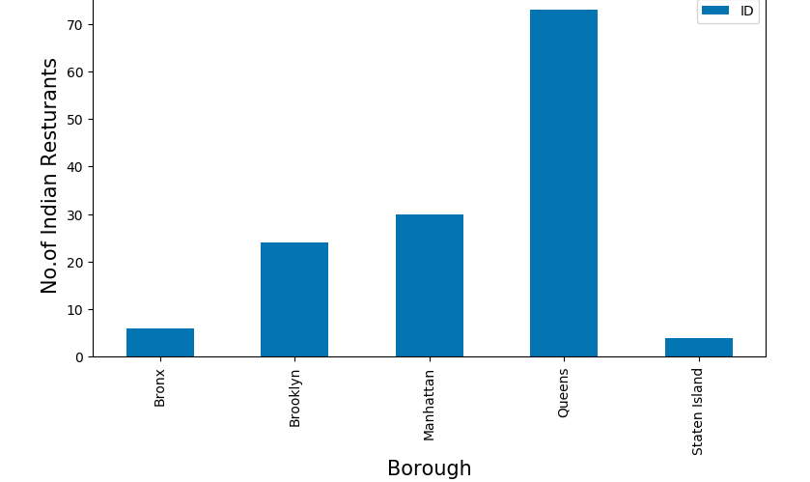

Floral Park in Queens has the highest number of Indian Restaurants

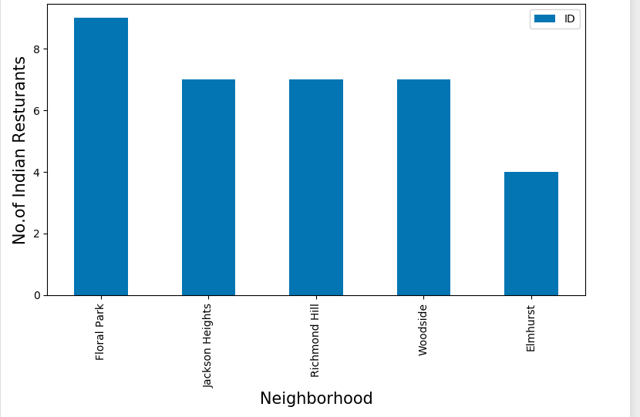

Conclusion

Queens has best neighborhoods for Indian cuisine. Staten Island ranks last in average rating.